**ANALYTICAL STUDY-I**

**Hemalatha**

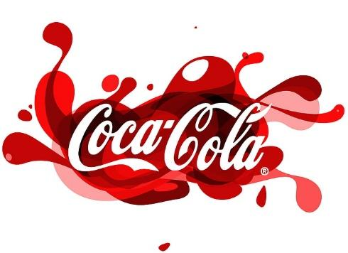

The Coca-Cola Company is a household name in the beverage industry thanks to their signature soda, Coca-Cola, which is carbonated and sweet. It was founded in Atlanta, Georgia, by John S. Pemberton in 1886, and today sells a wide variety of beverages, including Diet Coke, Sprite, and Fanta. It has a vast distribution network and operates in more than 200 nations. All people are familiar with the recognisable red and white Coca-Cola logo.

**SEGMENTATION:**

Marketsegmentation is the practice of dividing customers in to groups of potential buyers that have similar preferences and buying habits.

**Demographic**: It involves dividing market based on factors such as Age, Gender, Occupation.

1. Coke segments the small children introducing tastes like Vanilla, Lime and Cherry. They focused children from 4-12.
2. Oasis juice is made for the younger working adults, between 20-30.
3. Diet coke target adults between 30-50they are health conscious but want the taste.
4. Coco cola zero for diabetic people.
5. PowerAde sport drink and Coco cola energy for athlets.

**Psychographic**: according to this segmentation some patterns such as rate of usage, readiness to purchase. Coco cola introduce special prices with some beverages. The customers are seeking benefits are targeted.

**Geographic:** coco cola sells its products globally and target different cultures, customs, and climates. In America, it is most liked by older people too. It also varies the change accordingly, like the Asian version is sweeter than other countries.

**TARGETING:**

Coca-Cola targets multiple consumer segments simultaneously. It aims to reach a wide range of audiences, including teenagers, young adults, families, and people from various cultural backgrounds. By doing so, they can appeal to different tastes and preferences and expand their market reach.

**POSITIONING:**

Coca-Cola positions its products as refreshing, enjoyable, and associated with moments of happiness, togetherness, and celebrations. It emphasizes its heritage, global presence, and iconic branding to maintain its position as a market leader and a symbol of happiness.

**ANALYTICAL STUDY-I**

**Hemalatha**

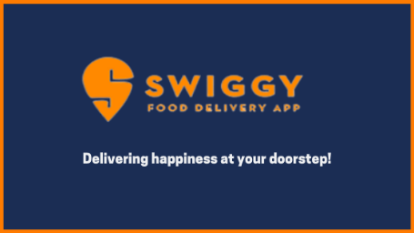

**Introduction**

Swiggy is an online food ordering platform. It connects people with restaurants. People can use Swiggy app or website to look for eateries around their area and order food from them. Swiggy has a team of delivery executives who pick up the order from the restaurants and deliver it to the address provided by the customer.

Started in **2014** by **Nandan Reddy, Sriharsha Majety, and Rahul Jaimini**, it expanded exponentially, and it now has over **40,000 restaurant partners** spread over more than **44 cities in the country**.

**Marketing Strategies**

### ****Discounts and Promotions:** Swiggy often offers discounts, cashback offers, and promo codes to attract and retain customers. These promotions are frequently used to incentivize first-time users and encourage repeat orders.**

### ****Referral Programs:** Swiggy has implemented referral programs where existing customers can refer friends and family to the platform in exchange for rewards or discounts on future orders. This strategy leverages word-of-mouth marketing.**

### ****Partnerships and Tie-ups:** Swiggy partners with various restaurants and eateries to offer a wide range of food options to its customers. These partnerships help in expanding their menu and attracting a diverse customer base.**

### ****Swiggy Super:** Swiggy Super is a subscription-based loyalty program that offers benefits such as free deliveries, exclusive discounts, and faster delivery times to its members. This program encourages customer retention and higher order frequency.**

### ****Targeted Advertising:** Swiggy uses data-driven advertising to target specific user segments with personalized promotions and recommendations. They send emails and push notifications to users based on their ordering history and preferences.**

### ****Social Media Marketing:** Swiggy maintains an active presence on social media platforms like Facebook, Instagram, Twitter, and YouTube. They use these platforms to engage with customers, share food-related content, and run advertising campaigns.**

### ****Innovative Campaigns:** Swiggy occasionally runs creative marketing campaigns and contests on social media to generate buzz and engage with customers. For example, they have run campaigns like #SwiggyVoiceofHunger and #SwiggyStarHunt.**

### ****Localized Marketing:** Swiggy tailors its marketing efforts to specific cities and regions, understanding the local food culture and preferences to better connect with the target audience.**

### ****Customer Feedback and Improvement:** Swiggy actively seeks feedback from customers through its app and website. They use this feedback to make improvements in their service and address customer concerns, demonstrating a commitment to customer satisfaction.**

### ****Sponsorships and Events:** Swiggy has sponsored events and partnered with popular sports leagues and tournaments to increase brand visibility and reach a broader audience.**